

SEMESTER TWO

MATHEMATICS METHODS
UNITS 1 & 2

2015

SOLUTIONS
Calculator−free Solutions

1. (a) 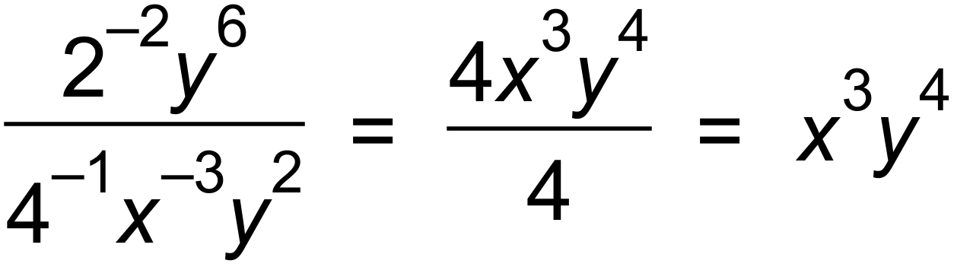 ✓✓
(b) 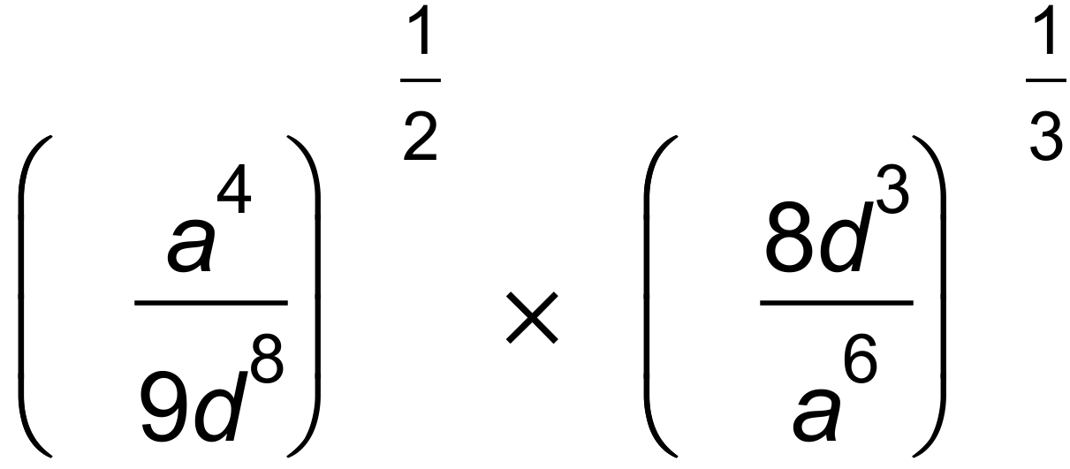 ✓
= 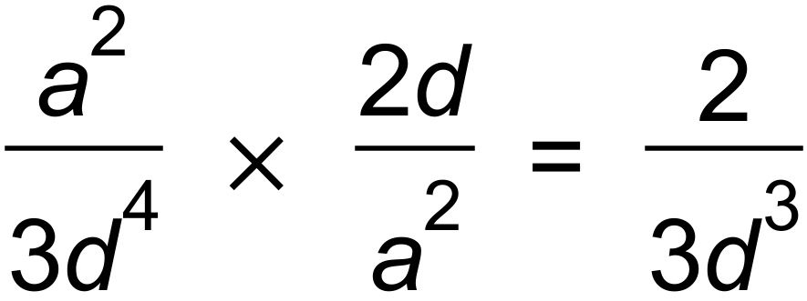 ✓✓ [5]

2. (a) 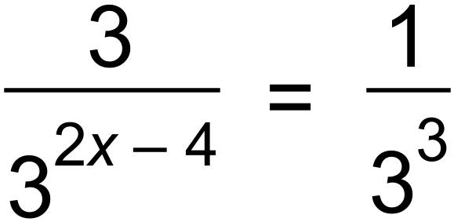
∴ 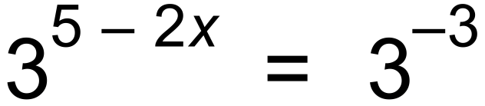 ✓
∴ 5 − 2x = −3
∴ x = 4 ✓
(b) 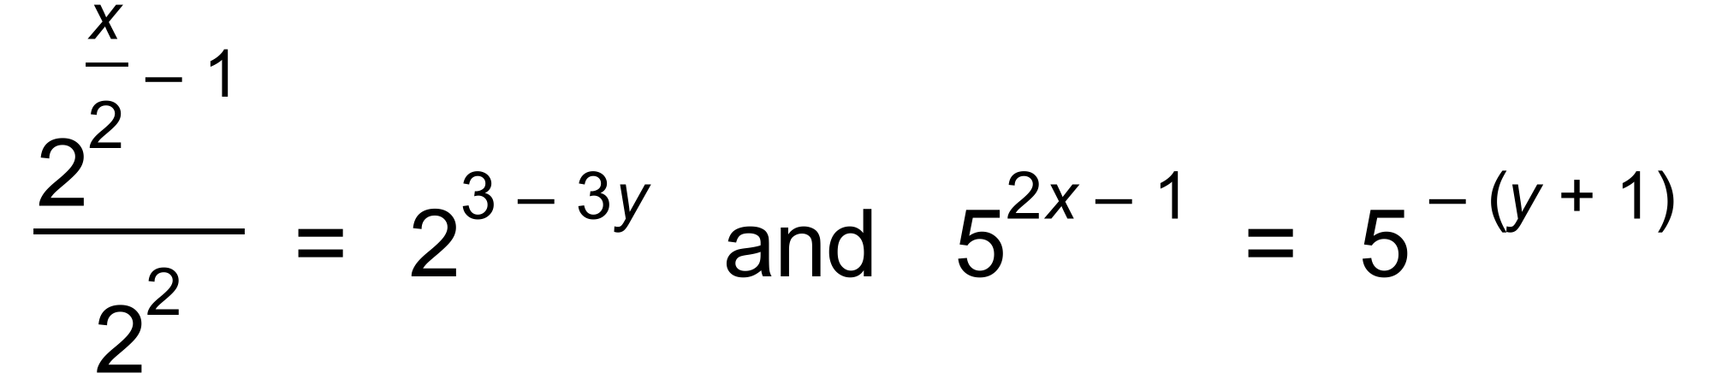 ✓
∴ 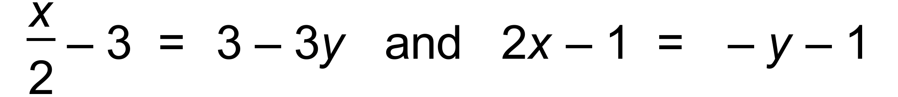 ✓
∴ ✓
∴ x = 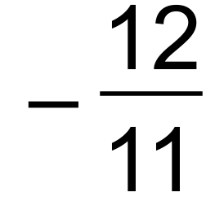 and y = 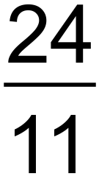 ✓ [6]

3. (a) (i) ✓✓
(ii) 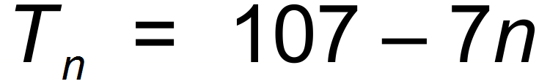 ✓
(b) 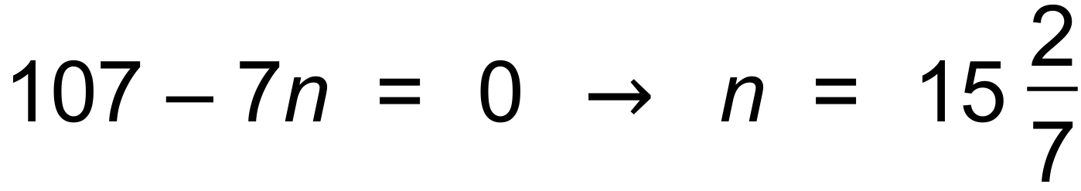 ✓
∴ 15 terms ✓
(c) ✓ [6]

4. (a) 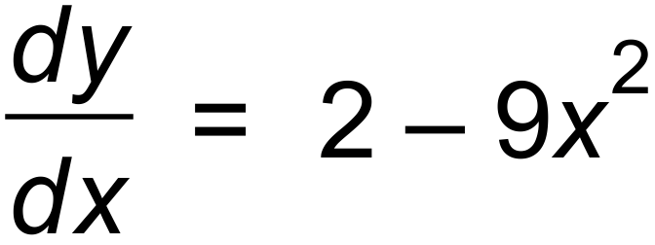 ✓✓
(b) 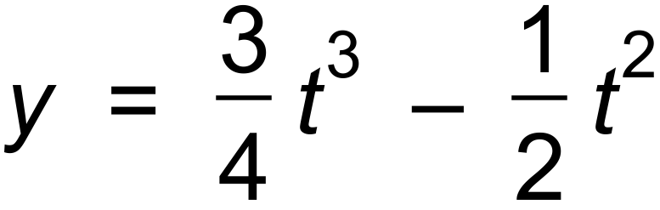
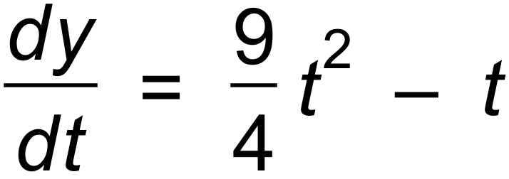 ✓✓
(c) 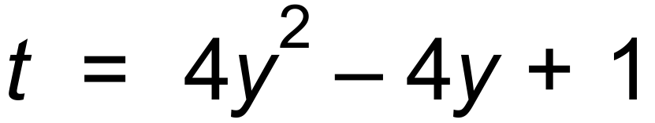 ✓
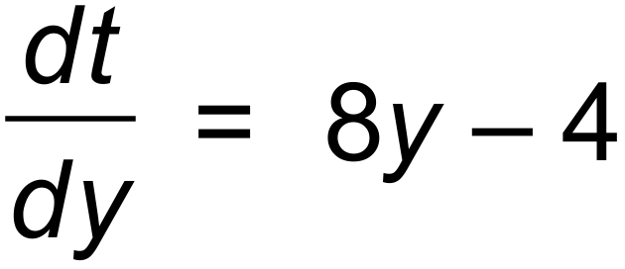 ✓✓ [7]

5. (a) 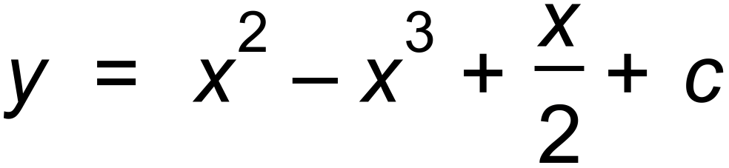 ✓✓
(b) 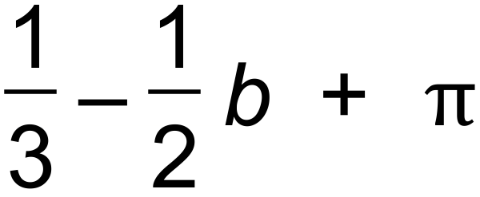 ✓
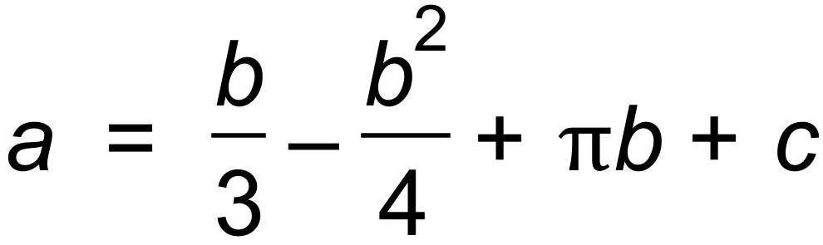 ✓✓
(c) 4n³ + 12n² + 9n ✓
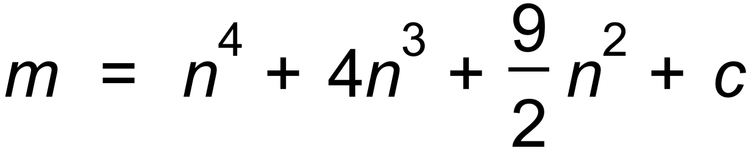 ✓✓ [8]

6. (a) (i) 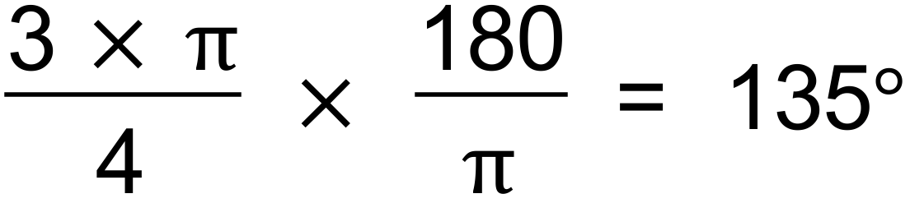 ✓
(ii) 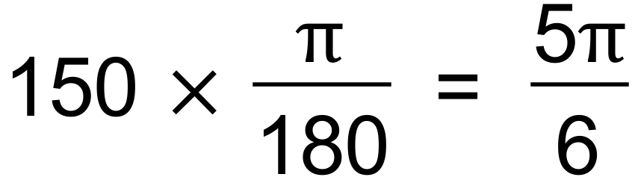 ✓
(b)
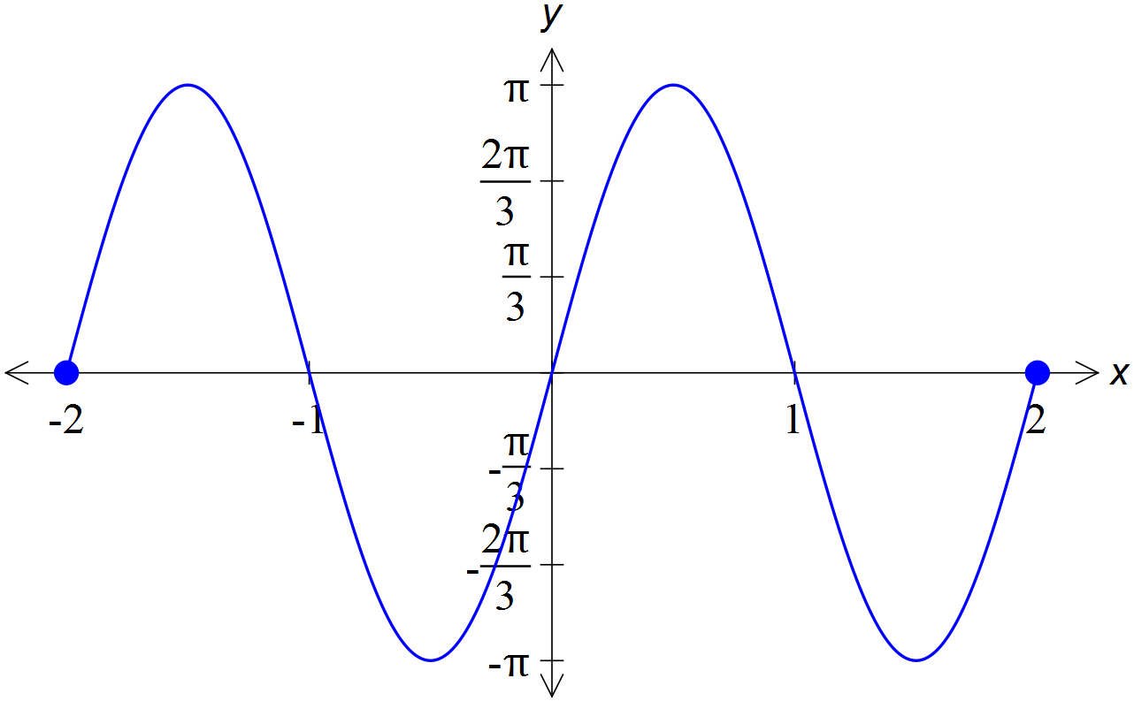

✓✓✓ [5]

7. (a) 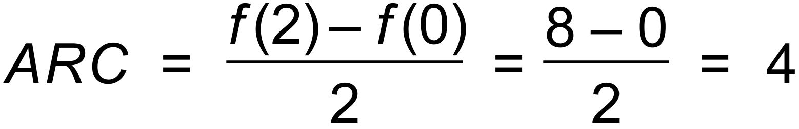 ✓✓
(b)
∴
∴ 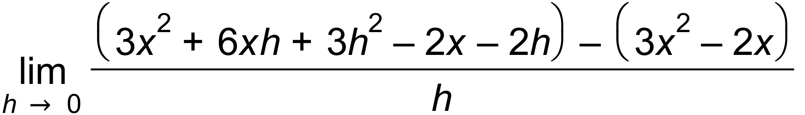 ✓
IRC = 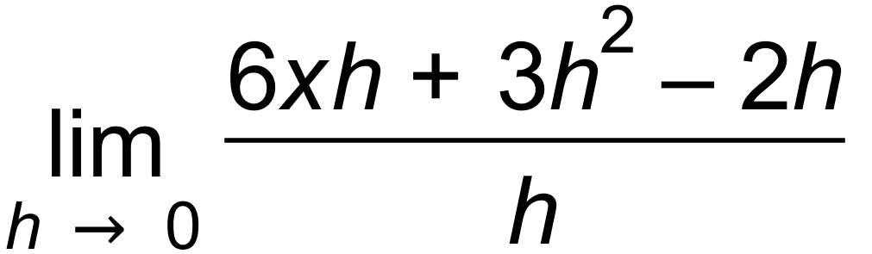
= 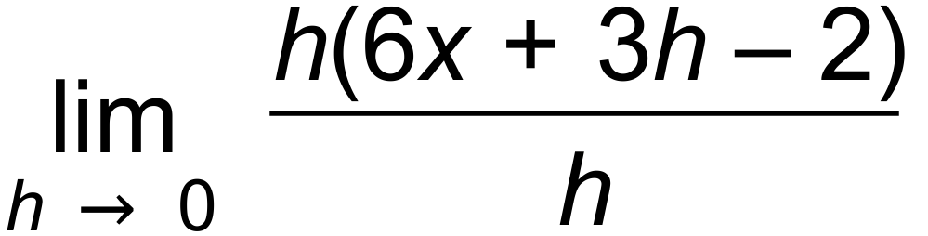 ✓
= 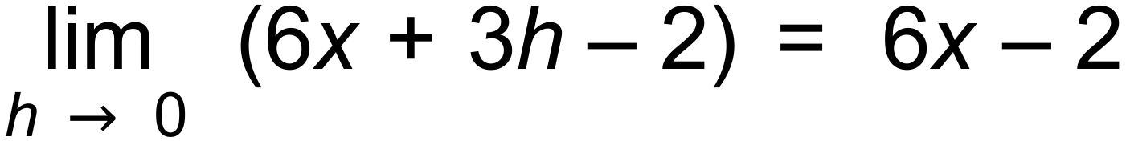 ✓
IRC(1) = 4 ✓
(c) 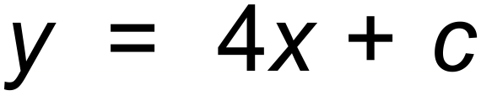 ✓
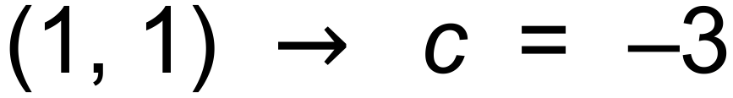
∴ 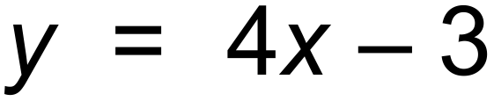 ✓ [8]

8. (a)
 | Male | Female | Total
Affirmative | 18 | 24 | 42
Negative | 11 | 7 | 18
Total | 29 | 31 | 60
✓
(b) (i) 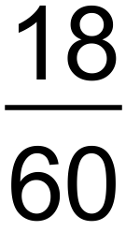 ✓
(ii) 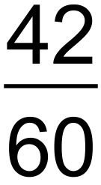 ✓
(iii) 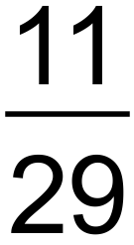 ✓
(c) P(M|A) = 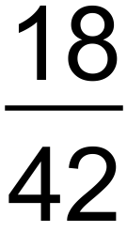 and P(M) = 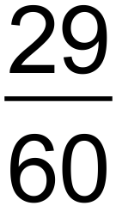
∴ Since P(M|A) 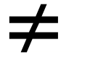 P(M), not independent. ✓ [5]

Calculator−assumed Solutions

9. (a) 11, 8, 5 ✓
(b) 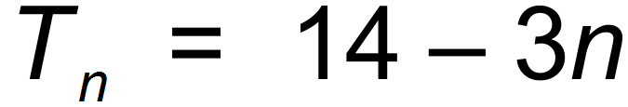 ✓✓
(c) 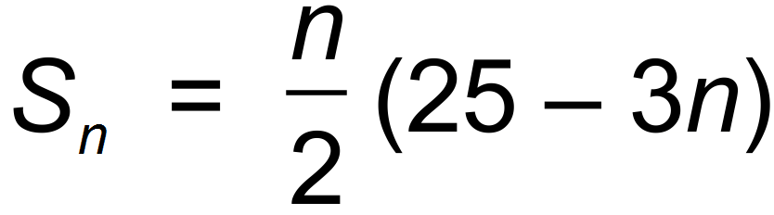 ✓✓
(d) 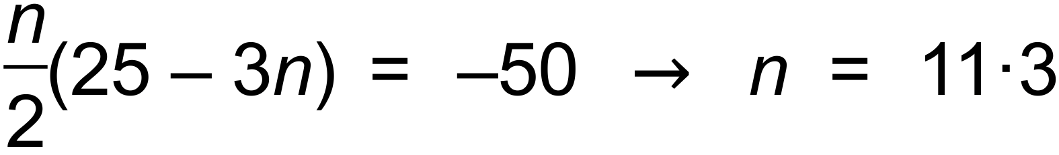 ✓
∴ 12 terms ✓ [7]

10. (a) (i) 12 m ✓
(ii) 2.1 s ✓
(iii) 1 or 3 s ✓
(iv) 36 m ✓
(b) 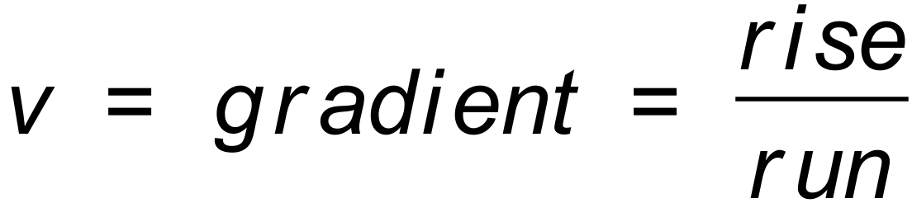
∴ between ( 0.6, 6) and (1.4, −6) ✓
∴  ✓ [6]

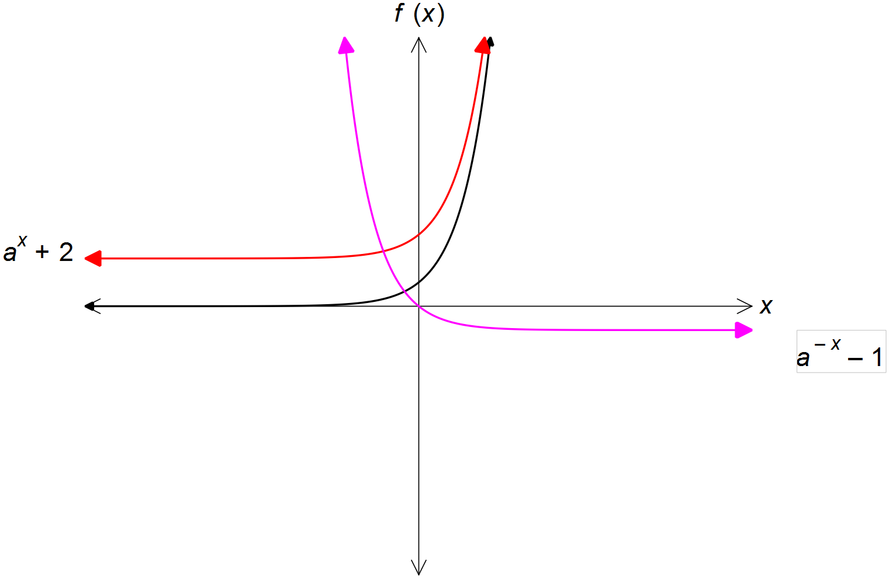11. (a)

✓✓✓✓
(b) (ii), (iii) ✓✓ [6]

12. (a) (i) 0.1 ✓
(ii) f(2.2) − f(2.1) = 1.152 − 2.139 = −0.987 ✓✓
(b) f ′(x) = 4 − 3x² ✓
∴ f ′(2) = −8 ✓
(c) 4 – 3x² = 0 ✓
(-1.15,6.08) (1.15,-3.12) ✓ [7]

13. (a) Geometric ✓
(b) (i) ✓✓
(ii) ✓✓
(iii) 189.1 mL ✓✓
(c) 36th Day ✓✓
(d) 2758 mL ✓✓
(e) 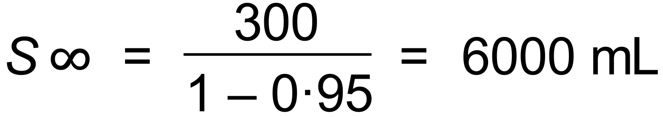 ✓
∴ Never overflow ✓ [13]
14. (a) (i) −b, 1 and −1 ✓
(ii) (0, −ab) ✓
(b) (i) a > 0 ✓
(ii) a < 0 ✓
(c) (i) b = 0 ✓
(ii) b = 1 ✓
(d) ✓
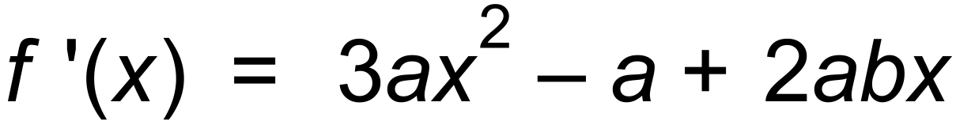 ✓ [8]

15. (a) (i) (e, f) ✓
(ii) (g, h) ✓
(iii) (e, f) ✓
(iv) (c, d) and (e, f) ✓✓
(b) (i) 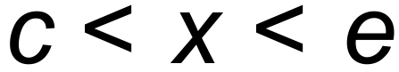 ✓
(ii) ✓✓ [8]

16. (a) P = 2x + 2y
∴ ✓
∴ 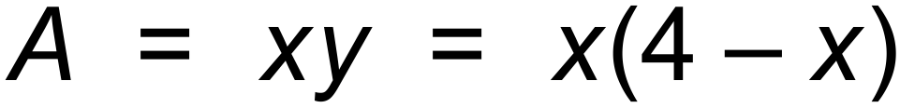 ✓
(b) 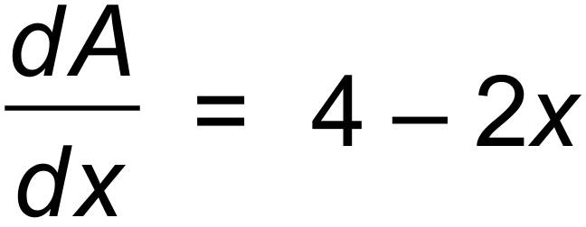 ✓
∴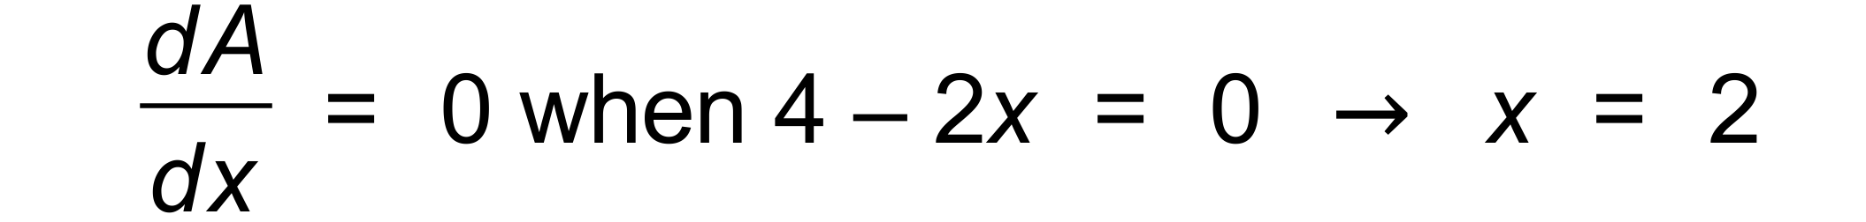 ✓
∴ A = 4 m² ✓
(c)
x | 2− | 2 | 2+
A′ | + | 0 | −
A | / | − | \
✓ [6]

17. (a) (i) 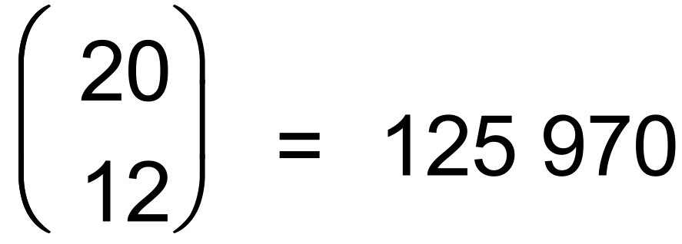 ✓
(ii) 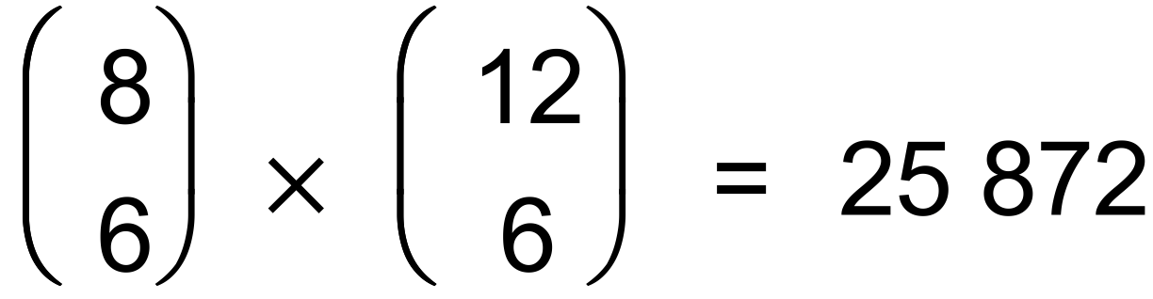 ✓✓
(iii) 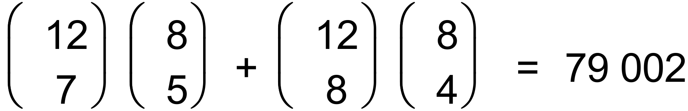 ✓✓
(b) (i) 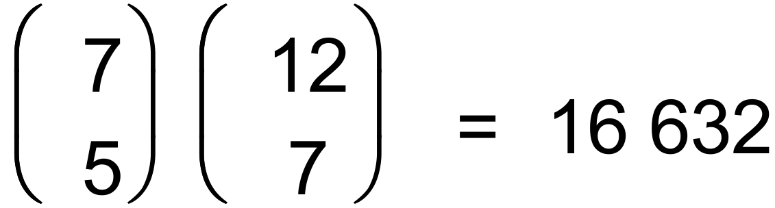 ✓✓
(ii) 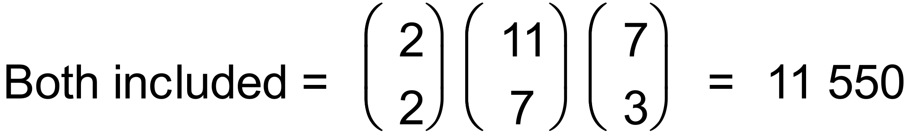 ✓
∴ 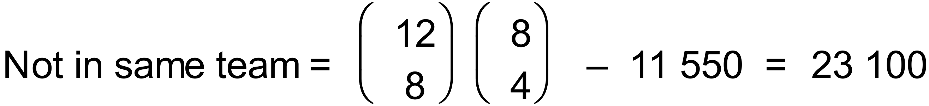 ✓ [9]

18. (a) 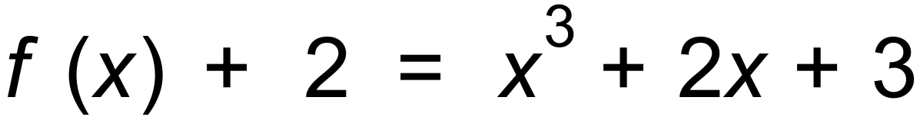 ✓
(b) ✓
(c) 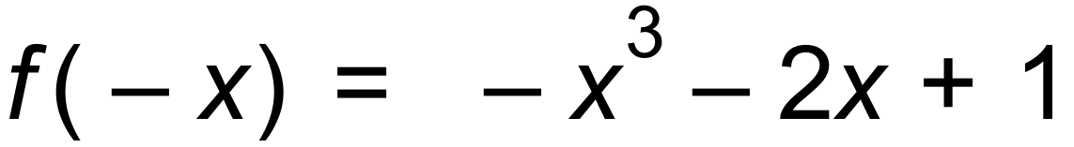 ✓
(d) ✓✓
(e) 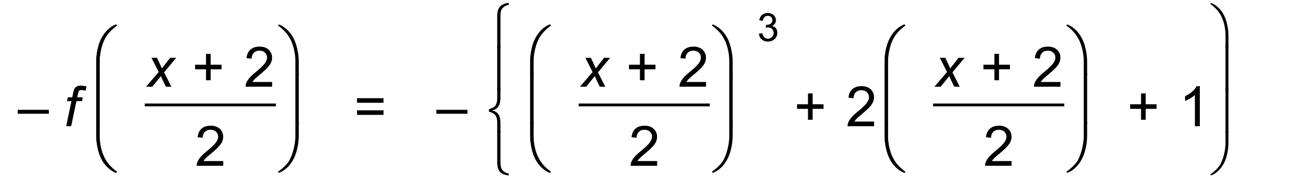 ✓✓
= 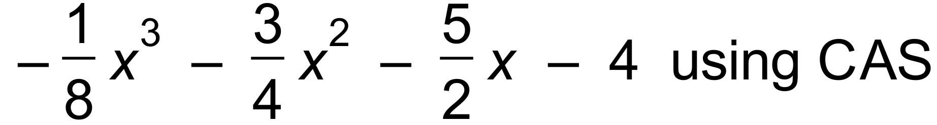 ✓ [8]

19. (a) ✓
∴ 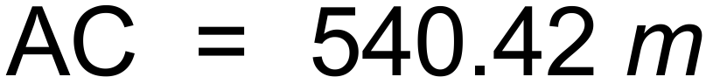 ✓
(b) 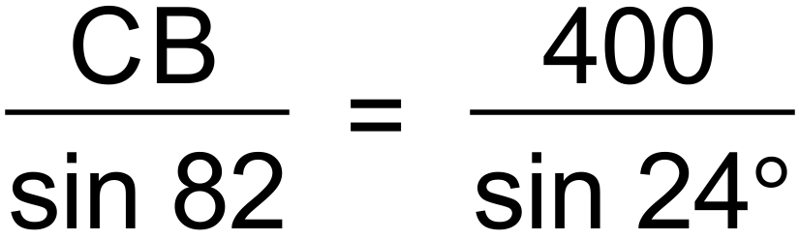 ✓
∴ 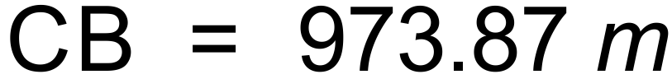 ✓
(c) ✓✓
∴ ✓ [7]

20. (a) 8 ✓
(b) (i) 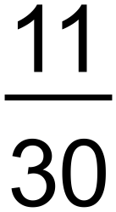 ✓
(ii) 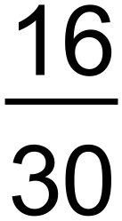 ✓
(iii) 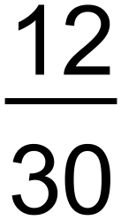 ✓
(iv) 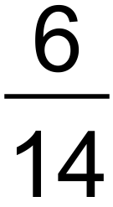 ✓✓
(c) Is male and plays Tennis and Badminton ✓
(d) Since P(M ∩ B) ≠ 0 ✓ [8]

21. (a)
A | B | C | D
iii | iv | ii | i

✓✓✓✓
(b) 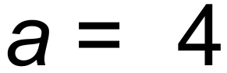 ✓
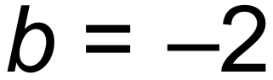 ✓
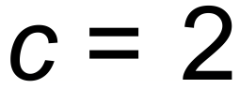 ✓ [7]

